**Day1**

* Basic introduction to all topics in 6 month plan
* Laptop guideline for the course ram 16gb, i5 th G, ssd, nvidia Graphics card etcc
* **Create IDs on**

1. <https://www.perplexity.ai/>
2. Claude.ai
3. Chatgpt
4. Poe.com
5. Bing ai
6. Google bard
7. Llama 2 using labs.perplexity.ai
8. Huggingface.com

* **Use vscode extension**

1. Jellyfish theme
2. Prettier
3. Vscode icons

* **Q&A**

**Day2**

**What is artificial intelligence?**

It refers to computer systems or machines that are capable of performing tasks that typically require human intelligence, such as visual perception, speech recognition, decision-making, and language translation.

**Key charateristics:**

**Learning**- AI systems can learn from data and improve their capabilities over time without being extremely programmed. Machine learning and deep learning are subsets of AI.

**Reasoning**—AI systems can use logic and inference rules to solve the problems. Systems can complete tasks by analyzing

**Adaptability**-

**Robotics-**

Al is being used to develop autonomous robots and vehicles that can perform tasks without human oversight.

**ANI VS AGI**

**Narrow AI:** Focused on singled defined tasks humans in specialized domains Based on current Al capabilities

Examples are chess machines, self-driving cars.

**General Al**

Has general intelligence and capabilities can reason, plan, communicate across

Domains adapts to new environments and t inspirationally aims to mimic human Intelligence.

**AI vs data Science vs ml vs dl:**

Here's a brief comparison of AI, Data Science, Machine Learning (ML), and Deep Learning (DL):

1. **Artificial Intelligence (AI)**:
   * **Definition**: AI refers to the simulation of human intelligence processes by machines, especially computer systems. It encompasses a broad range of technologies designed to perform tasks that normally require human intelligence, such as problem-solving, reasoning, planning, and language understanding.
   * **Scope**: Encompasses a wide array of subfields, including machine learning, natural language processing, robotics, and expert systems.
2. **Data Science**:
   * **Definition**: Data Science is the field that combines statistical methods, algorithms, and domain knowledge to extract insights and knowledge from structured and unstructured data. It's an interdisciplinary field that focuses on analyzing and interpreting complex data to aid decision-making.
   * **Scope**: Involves data collection, cleaning, exploration, modeling, and visualization, often using machine learning and statistical techniques.
3. **Machine Learning (ML)**:
   * **Definition**: ML is a subset of AI that involves the development of algorithms that enable computers to learn from and make predictions or decisions based on data, without being explicitly programmed for specific tasks.
   * **Scope**: Encompasses supervised learning, unsupervised learning, and reinforcement learning, and is widely used in tasks like classification, regression, and clustering.
4. **Deep Learning (DL)**:
   * **Definition**: DL is a subfield of machine learning that uses neural networks with many layers (hence "deep") to model complex patterns in large amounts of data. It excels in tasks like image recognition, speech processing, and natural language understanding.
   * **Scope**: A more advanced form of ML, particularly suited for working with large datasets and high-complexity tasks (e.g., self-driving cars, automated language translation).

In summary:

* **AI** is the overarching concept of machines simulating human intelligence.
* **Data Science** focuses on extracting knowledge from data.
* **ML** is a subset of AI that enables machines to learn from data.
* **DL** is a subset of ML focused on neural networks and large-scale learning tasks.

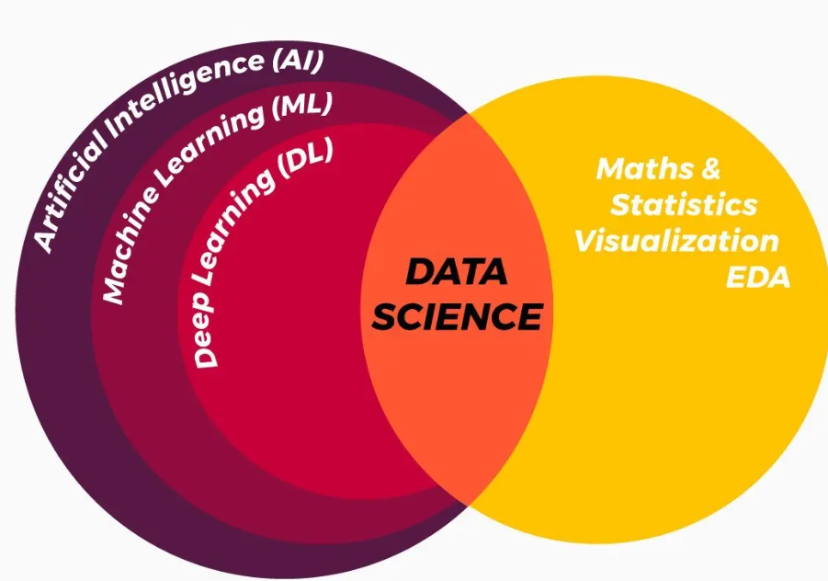

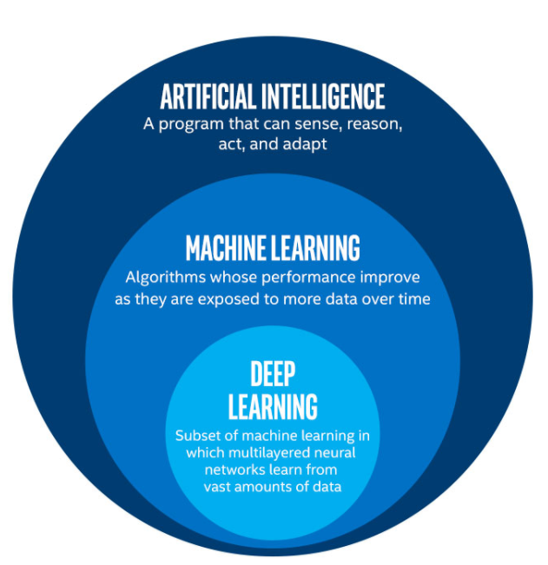

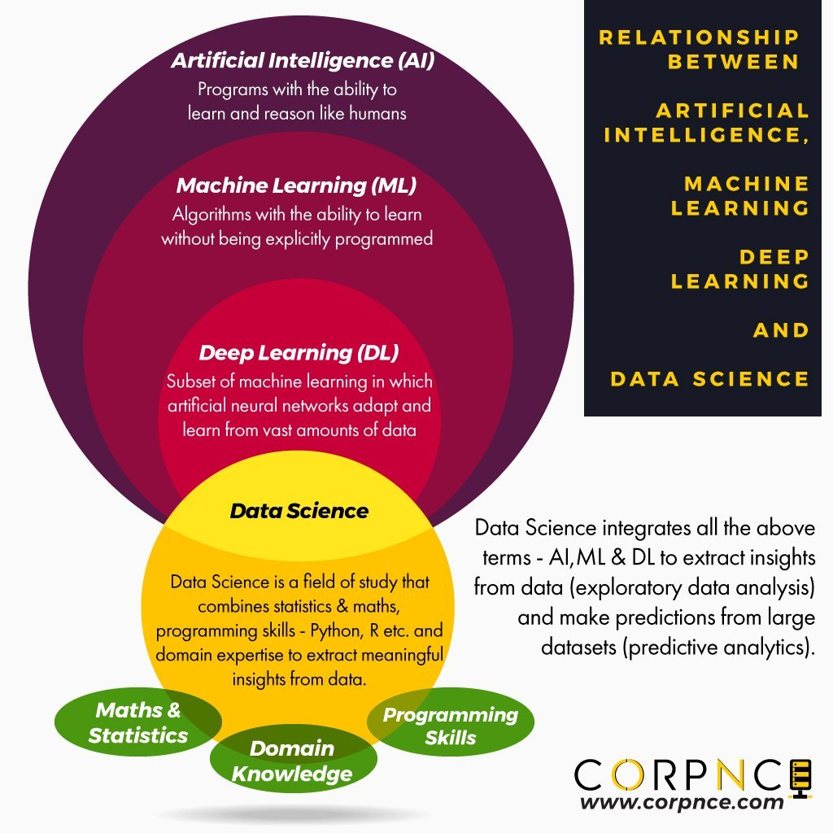

**Big players in AI:**

* Google
* Microsoft
* Meta
* Amazon
* IBM
* Intel tesla
* Nvidia
* OpenAi

And many more……

**Assignment-2: Large language model (LLM)**

**Benefits of AI in our daily life:**

Artificial Intelligence (AI) is rapidly transforming our world, offering numerous benefits across various aspects of our daily lives. Here are some key advantages:

**Enhanced Healthcare**

* **Disease Diagnosis:** AI-powered tools can analyze medical images and patient data to accurately diagnose diseases like cancer and heart disease.
* **Drug Discovery:** AI accelerates drug discovery by analyzing vast amounts of data to identify potential drug candidates.
* **Personalized Medicine:** AI can tailor treatments to individual patients based on their genetic makeup and medical history.

**Improved Education**

* **Personalized Learning:** AI-powered educational platforms can adapt to each student's learning style and pace, providing personalized learning experiences.
* **Intelligent Tutoring Systems:** AI-powered tutors can provide real-time feedback and support to students, enhancing their learning outcomes.

**Enhanced Productivity**

* **Automation of Tasks:** AI can automate repetitive tasks, freeing up human workers to focus on more creative and strategic work.
* **Data Analysis:** AI-powered tools can analyze large datasets to extract valuable insights and make data-driven decisions.

**Safer and Smarter Cities**

* **Traffic Management:** AI can optimize traffic flow, reduce congestion, and improve public transportation systems.
* **Public Safety:** AI-powered surveillance systems can help identify and prevent crime.
* **Smart Homes:** AI-enabled devices can automate various tasks, such as controlling lights, thermostats, and security systems.

**Economic Growth**

* **Innovation:** AI drives innovation by enabling the development of new products and services.
* **Job Creation:** While AI may automate some jobs, it also creates new job opportunities in AI development, data science, and other related fields.

**Improved Customer Experience**

* **Personalized Recommendations:** AI-powered recommendation systems can suggest products and services tailored to individual preferences.
* **Efficient Customer Service:** AI-powered chatbots can provide instant customer support, answering questions and resolving issues.

In conclusion, AI has the potential to revolutionize many aspects of our lives, making them more efficient, convenient, and enjoyable. As AI continues to evolve, we can expect even more exciting developments and benefits in the years to come.

**The Influence of AI on Our Daily Lives**

Artificial intelligence (AI) has become an integral part of our daily lives, shaping the way we interact with technology and the world around us. Here are some key areas where AI is making a significant impact:

**1. Enhanced Personalization**

* **Tailored Recommendations:** AI algorithms analyze user behavior and preferences to provide personalized recommendations for products, movies, music, and more.
* **Customised Content:** AI-powered platforms adapt content to individual interests, making online experiences more engaging and relevant.

**2. Improved Healthcare**

* **Disease Diagnosis:** AI-driven tools can analyze medical images and patient data to detect diseases like cancer early.
* **Drug Discovery:** AI accelerates drug discovery by analyzing vast datasets to identify potential drug candidates.
* **Personalized Treatment:** AI can help tailor treatment plans to individual patients based on their genetic makeup and medical history.

**3. Enhanced Productivity and Efficiency**

* **Automation:** AI-powered automation tools can streamline tasks, reducing human error and increasing productivity.
* **Data Analysis:** AI can analyze large datasets to extract valuable insights, helping businesses make informed decisions.

**4. Revolutionizing Communication**

* **Language Translation:** AI-powered translation tools facilitate communication across language barriers.
* **Voice Assistants:** Virtual assistants like Siri, Alexa, and Google Assistant use AI to understand and respond to voice commands.

**5. Advancements in Transportation**

* **Self-Driving Cars:** AI is driving the development of self-driving cars, which promise to improve safety and efficiency.
* **Traffic Optimization:** AI-powered traffic management systems can optimize traffic flow and reduce congestion.

**6. Financial Services**

* **Fraud Detection:** AI algorithms can detect fraudulent activities in real-time.
* **Algorithmic Trading:** AI-powered trading systems can make rapid, data-driven investment decisions.

While AI offers tremendous potential, it's important to address ethical concerns and potential job displacement. However, with responsible development and implementation, AI can be a powerful force for positive change.